Objective of the Lab/Program

The program is meant to print all elements in the array of onto the screen.

Assembly Source Codes

##complete the program below to print the array of numbers on the screen
##complete the program in the places where "WRITE CODE" is mentioned
## 4 lines of code need to be written to complete the program
.data
list1: .word 10, 22, 45, 80, 60 #list1 is the name of the array (.word is used to initialize it)
size: .word 5 #to define list1, 20 bytes in the memory are stored since each number is 4 bytes
str: .asciiz "Array in MIPS\n"
.text
main:
la $a0, str
li $v0, 4 #print string
syscall

la $t1, list1
lw $t3, size #load word is used here to since it is stored in the data memory

##print numbers
print_list:
.data
space: .asciiz "\n" #new-line between numbers
.text

li $t2, 0 #loop counter

printing_loop:
beq $t2, $t3, exit #check if all numbers in the array are printed

lw $a0, ($t1) #get index of array
li $v0, 1
syscall

la $a0, space
li $v0, 4
syscall

addi $t2, $t2, 1
addi $t1, $t1, 4
j printing_loop

exit:
li $v0, 10
syscall

# END OF PROGRAM

Screen shot of the results
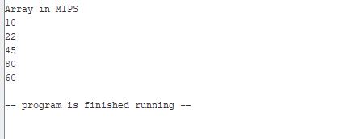

Conclusion and References

Using the load word instruction allows for the address of the array to be dereferenced to return the value it contains at the current address. Afterwards four bytes is added to the address, to output the following numbers in the array.

